1.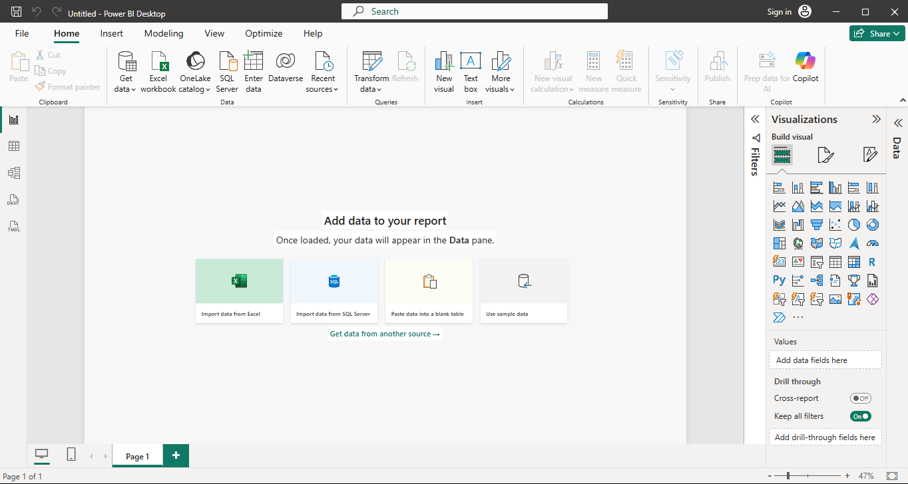

Component | Short Description
1. Report View | Used to create and design reports/dashboards by adding charts, tables, cards, slicers, and other visuals. This is where the final report pages are built.
2. Data View | Displays the actual data in table format. It allows you to inspect columns, rows, data types, and perform basic data checking.
3. Model View | Shows the relationships between different tables in the dataset. It is used to create or manage relationships and understand the data model.
4. Fields Pane | Contains the tables, columns, and measures available in the data model. You can drag these fields onto visuals to analyze the data.
5. Visualizations Pane | Provides different chart and visualization options such as bar charts, line charts, pie charts, cards, maps, etc. It is also used to format and customize visuals.
6. Filters Pane | Used to filter the data displayed in reports and visuals. Filters can be applied at the visual, page, or entire report level.
2.
3.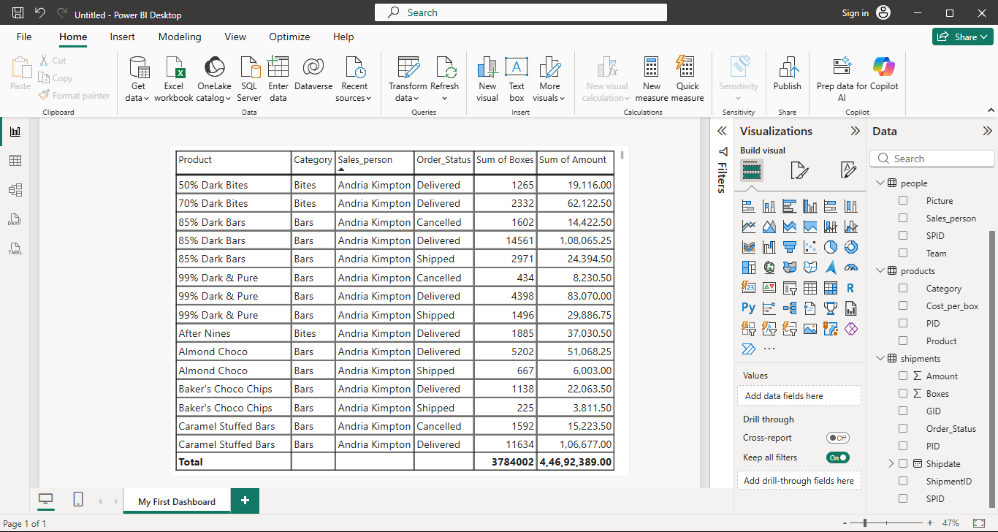
4.
Feature | Excel Dashboard | Power BI Dashboard
1. Data Handling | Excel is mainly spreadsheet-based; data is usually organized in worksheets and tables. | Power BI is designed for data modelling, allowing multiple tables to be connected through relationships.
2. Visualizations & Interactivity | Charts and Pivot Charts provide interactivity, but it is comparatively limited. | Power BI offers more interactive visuals, slicers, cross-filtering, drill-down, and tooltips.
3. Workflow & Reporting | Dashboard creation often involves formulas, PivotTables, and manually arranging charts on a worksheet. | Power BI uses Report View, Data View, and Model View, making it easier to build multi-page interactive reports and manage the data model.

